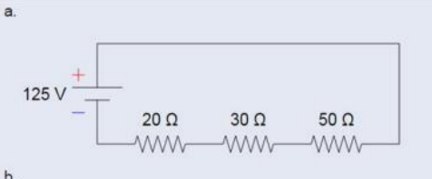
- Calculate the total resistance in ohms
Total Resistance: 20 + 30 + 50 = 100 Ω

- Calculate the total current from the power supply
Total Current: I = V / R = 125 / 100 = 1.25 A

- Calculate the current through each resistor
1.25 A each
4. Calculate the Voltage drop through each resistor
R1 (20 Ω): 1.25 × 20 = 25 V
R2 (30 Ω): 1.25 × 30 = 37.5 V
R3 (50 Ω): 1.25 × 50 = 62.5 V
- Calculate the Power dissipated through each resistor (use Watt’s Law: Power = Voltage * Current)
R1: 25 × 1.25 = 31.25 W
R2: 37.5 × 1.25 = 46.875 W
R3: 62.5 × 1.25 = 78.125 W

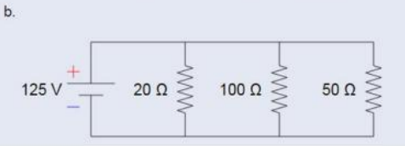
- Calculate the total resistance in ohms
1/20 + 1/100 + 1/50 = 5/100 + 1/100 + 2/100 = 8/100 = 12.5 Ω
- Calculate the total current from the power supply
I = V / R = 125 / 12.5 = 10 A

- Calculate the current through each resistor
R1 (20 Ω): 125 / 20 = 6.25 A
R2 (100 Ω): 125 / 100 = 1.25 A
R3 (50 Ω): 125 / 50 = 2.5 A

- Calculate the Voltage drop through each resistor
125 V each

- Calculate the Power dissipated through each resistor (use Watt’s Law: Power = Voltage * Current)
R1: 125 × 6.25 = 781.25 W
R2: 125 × 1.25 = 156.25 W
R3: 125 × 2.5 = 312.5 W
Total: 781.25 + 156.25 + 312.5 = 1,250 W

